Project Design Phase-II
Data Flow Diagram & User Stories
Project Name | AI FAQ Assistant API
Date | 30TH SEPTEMBER 2026
Team ID | SWTID-2026-8914

Data Flow Diagrams (DFD)

DFD Level 0 – Context Diagram
Description: The Level 0 Data Flow Diagram represents the AI FAQ Assistant API as a single system and shows how external users and services interact with it. Users can register, log in, search FAQs, and receive answers. Administrators and customer care executives can manage FAQs, while the system stores data in MongoDB and uses Google Gemini AI to generate AI-assisted responses.
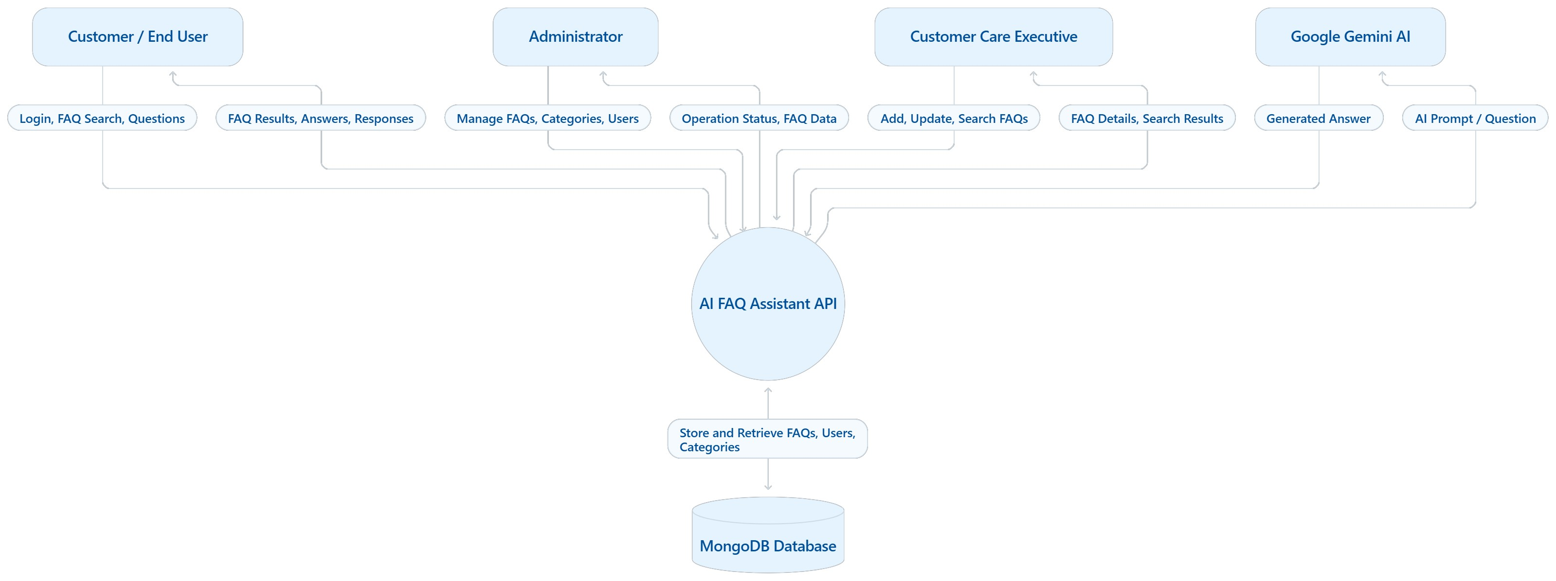

DFD Level 1 – Detailed Data Flow
Description: The Level 1 DFD breaks the AI FAQ Assistant API into its major processes: user authentication, FAQ management, FAQ search, and AI-powered answer generation. The Express.js API receives requests, validates them, interacts with MongoDB through Mongoose, and returns responses in JSON format. JWT is used for authentication, and bcrypt is used for password hashing.
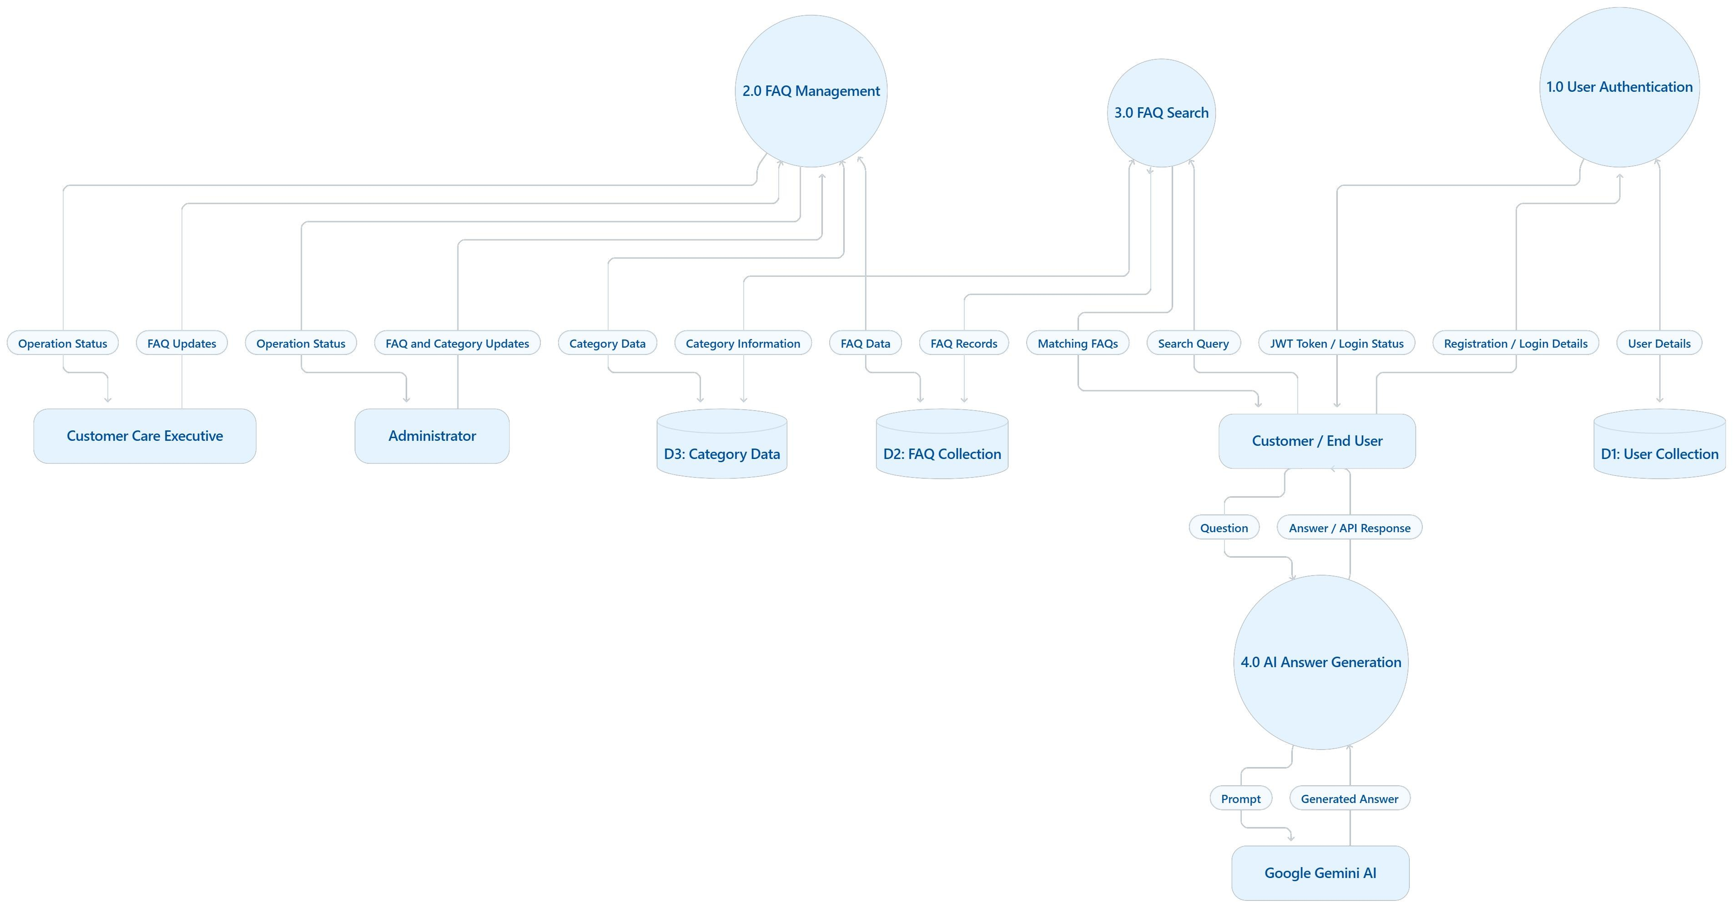

Main Data Stores
Data Store | Description
D1 – User Collection | Stores registered user details and securely hashed passwords.
D2 – FAQ Collection | Stores FAQ questions, answers, and related information.
D3 – Category Data | Stores FAQ categories used to organize and filter FAQs.
Note: The diagrams show the main logical data flows. The user, FAQ, and category data are stored in MongoDB. Authentication uses JWT and bcrypt, and AI-generated answers are obtained through the Google Gemini API.

User Stories
The following user stories use the template columns: User Type, Functional Requirement (Epic), User Story Number, User Story / Task, Acceptance Criteria, Priority, and Release.
User Type | Functional  Requirement (Epic) | User  Story  Number | User Story / Task | Acceptance Criteria | Priority | Release
Customer  (Web/Mobile User) | User Registration | USN-1 | As a user, I can register for the application by providing my required details. | The user account is created successfully when valid details are provided. Invalid or incomplete details are rejected. | High | Sprint-1
Customer  (Web/Mobile User) | User Login | USN-2 | As a user, I can log in using my registered credentials. | Valid credentials allow access. Invalid credentials return an appropriate error message. | High | Sprint-1
Customer  (Web/Mobile User) | Authentication | USN-3 | As a user, I can access protected API features using an authentication token. | A valid JWT grants access to protected endpoints. Missing or invalid tokens are rejected. | High | Sprint-1
Customer  (Web/Mobile User) | FAQ Search | USN-4 | As a user, I can search for FAQs using keywords related to my question. | The API returns matching FAQs. If no results are found, an appropriate response is displayed. | High | Sprint-1
Customer  (Web/Mobile User) | FAQ Browsing | USN-5 | As a user, I can view available FAQs and their answers. | The API returns the requested FAQ details in JSON format. | High | Sprint-1
Customer  (Web/Mobile User) | Category-Based Search | USN-6 | As a user, I can find FAQs by selecting or specifying a category. | FAQs belonging to the selected category are returned. Invalid categories are handled appropriately. | Medium | Sprint-2

User Type | Functional  Requirement (Epic) | User  Story  Number | User Story / Task | Acceptance Criteria | Priority | Release
Customer  (Web/Mobile User) | AI-Powered Answers | USN-7 | As a user, I can ask a question and receive an AI-generated answer. | The question is sent to Google Gemini AI, and the generated answer is returned through the API. | High | Sprint-2
Customer  (Web/Mobile User) | Error Handling | USN-8 | As a user, I receive a clear message when my request cannot be processed. | Invalid input, unavailable resources, and service errors return appropriate error responses. | Medium | Sprint-2
Customer Care Executive | FAQ Management | USN-9 | As a customer care executive, I can add new FAQs to help customers find answers. | Valid FAQ details are saved in MongoDB and can be retrieved through the API. | High | Sprint-2
Customer Care Executive | FAQ Management | USN-10 | As a customer care executive, I can update existing FAQ questions and answers. | The selected FAQ is updated successfully, and the changes are reflected in subsequent retrievals. | High | Sprint-2
Customer Care Executive | FAQ Management | USN-11 | As a customer care executive, I can delete outdated or incorrect FAQs. | The selected FAQ is removed, and the API confirms the operation. | Medium | Sprint-2
Administrator | Category  Management | USN-12 | As an administrator, I can create and manage FAQ categories. | Categories can be created, retrieved, updated, and managed through authorized API endpoints. | Medium | Sprint-2
Administrator | Access Control | USN-13 | As an administrator, I can restrict FAQ management operations to authorized users. | Protected operations require valid authentication and appropriate access permissions. | High | Sprint-2
Administrator | FAQ Oversight | USN-14 | As an administrator, I can view and maintain the FAQs stored in the system. | The administrator can retrieve FAQ records and perform permitted management operations. | Medium | Sprint-2
Administrator | API Reliability | USN-15 | As an administrator, I can receive consistent API responses for successful and failed requests. | API responses use a consistent JSON structure and appropriate HTTP status codes. | Medium | Sprint-2

Summary
The AI FAQ Assistant API provides a centralized platform for managing frequently asked questions and delivering automated customer support. The system allows customers to search FAQs, browse categories, and obtain AI-generated answers. Customer care executives can maintain FAQ content, while administrators oversee FAQ and category management.
The system uses Node.js and Express.js to build RESTful APIs, MongoDB and Mongoose for data storage, JWT and bcrypt for authentication and password security, and Google Gemini AI for generating AI-assisted responses. The DFDs illustrate the movement of data between users, API processes, the database, and the AI service, while the user stories define the functional requirements and acceptance criteria for development.

